Deploy Automotive App To Kubernetes

Course Name: Dev Ops
Institution Name: Medi - Caps University – Datagami Skill Based Course

Student Name(s) & Enrolment Number(s):

Sr no | Student Name | Enrolment Number
1 | Ayush Yadav | EN22CS301255
2 | Ayush Bangar | EN22CS301245
3 | Bhumika Gupta | EN22CS301277
4 | Bhupendra Yadav | EN22CS301282
5 | Charu Arya | EN22CS031289
6 | Rituraj Kumar Verma | EN23CS3L1015

Group Name: 12 D3
Project Number: DO-36
Industry Mentor Name: Mr. Vaibhav
University Mentor Name: Prof. Shyam Patel
Academic Year: 2022-26

Problem Statement & Objectives
Problem Statement
In traditional deployment systems, automotive applications are often hosted on fixed infrastructure, which leads to challenges such as limited scalability, inefficient resource utilization, and high downtime during failures or updates. Managing complex applications with multiple components becomes difficult, especially when handling increasing user traffic and real-time data processing. Manual deployment processes are time-consuming and prone to errors, affecting system reliability. Additionally, ensuring high availability, security, and consistent performance across different environments is a major challenge. There is a need for a modern solution that can automate deployment, efficiently manage resources, and provide scalability and fault tolerance. To address these issues, this project focuses on deploying an automotive application using Kubernetes and containerization with Docker.
Objectives
• To design and deploy a scalable automotive application using Kubernetes
• To implement containerization of the application using Docker for consistency across environments
• To ensure high availability and fault tolerance through automated container orchestration
• To enable auto-scaling of application services based on workload demand
• To implement CI/CD pipelines for automated build, testing, and deployment
• To improve system performance using load balancing and caching techniques
• To enhance security using authentication, authorization, and secure data handling
• To monitor system performance using logging and monitoring tools
• To reduce manual intervention and deployment errors through automation
2. Project Objectives
The main objectives of the Deploy Automotive App to Kubernetes are:

1. Containerization of Application
The objective is to package the automotive application and its dependencies into containers using Docker. This ensures that the application runs consistently across different environments like development, testing, and production without compatibility issues.

2. Orchestration Using Kubernetes
The project aims to deploy and manage containers using Kubernetes. Kubernetes automates tasks like container scheduling, deployment, and management, reducing manual effort.

3. Scalability
One of the key objectives is to enable auto-scaling of the application based on user demand. Kubernetes automatically increases or decreases the number of running containers (pods), ensuring the system handles traffic efficiently.

4. High Availability
The system is designed to remain available even if some components fail. Kubernetes ensures this by running multiple replicas of services and automatically restarting failed containers.

5. Fault Tolerance
The project focuses on building a system that can recover from failures without affecting users. Kubernetes provides self-healing features like automatic pod replacement and rescheduling.

6. CI/CD Automation
Another objective is to automate the build, testing, and deployment process using CI/CD pipelines. This reduces manual errors and allows faster and more reliable updates to the application.

7. Performance Optimization
The system is optimized for better performance using load balancing, caching, and efficient resource allocation. This ensures faster response times and smooth user experience.

8. Security Implementation
The project aims to secure the system by implementing authentication, authorization, and encryption. Sensitive data is protected using secure storage mechanisms within Kubernetes.

3. Scope of the Project

1. Technical Scope
The technical scope includes containerizing the automotive application using Docker and deploying it on Kubernetes. It involves implementing microservices architecture, managing containers, configuring networking, and ensuring scalability and fault tolerance. The project also covers CI/CD integration, monitoring, and logging to maintain system performance and reliability.
2. Functional Scope
The functional scope focuses on the core features of the automotive application such as user management, vehicle data handling, and analytics processing. It includes handling user requests through APIs, processing data, and returning responses efficiently. The system ensures smooth interaction between frontend and backend services.
3. Educational Scope
This project provides practical knowledge of modern technologies like containerization, orchestration, and DevOps practices. It helps in understanding real-world system deployment, microservices architecture, and cloud-native development. Students gain hands-on experience with tools and concepts widely used in the IT industry.
4. Industrial Scope
The project reflects real-world industry practices by implementing scalable and reliable deployment systems. It prepares the system for production-level environments where high availability, security, and performance are critical. Such architectures are widely used in industries like automotive, e-commerce, and cloud services.

5. Future Scope
In the future, the project can be enhanced by integrating advanced features such as AI-based analytics, real-time data processing, and IoT integration for smart vehicles. It can also be deployed on cloud platforms for global accessibility. Additional improvements may include advanced security, performance optimization, and multi-region deployment.

6. Limitations
• Complex Setup and Learning Curve
Setting up and managing Kubernetes requires good knowledge, which can be difficult for beginners.
• High Initial Configuration Effort
Configuring containers, clusters, networking, and CI/CD pipelines using Docker takes significant time and effort initially.
• Resource Consumption
Running a Kubernetes cluster may require higher CPU, memory, and infrastructure resources compared to traditional deployment.
• Debugging Complexity
Troubleshooting issues in a distributed microservices environment can be challenging due to multiple services and containers.
• Security Configuration Challenges
Properly securing the system (RBAC, network policies, secrets) requires careful setup and expertise.

Proposed Solution
1. Key Features
• Containerized Application Deployment using Docker
• Kubernetes-Based Orchestration using Kubernetes
• Microservices Architecture
• Auto-Scaling Capability
• Load Balancing
• High Availability and Fault Tolerance
• CI/CD Integration
• Monitoring and Logging
• Security Implementation
• Efficient Resource Utilization
2. Overall Architecture / Workflow
The overall architecture follows a microservices-based approach where the automotive application is containerized using Docker and deployed on a Kubernetes cluster. User requests are routed through an API Gateway to the appropriate services, while Kubernetes manages scaling, load balancing, and fault tolerance. The system ensures continuous operation with automated deployment, monitoring, and efficient resource management.
Step-by-Step Workflow:

1.Sequence Diagram :-
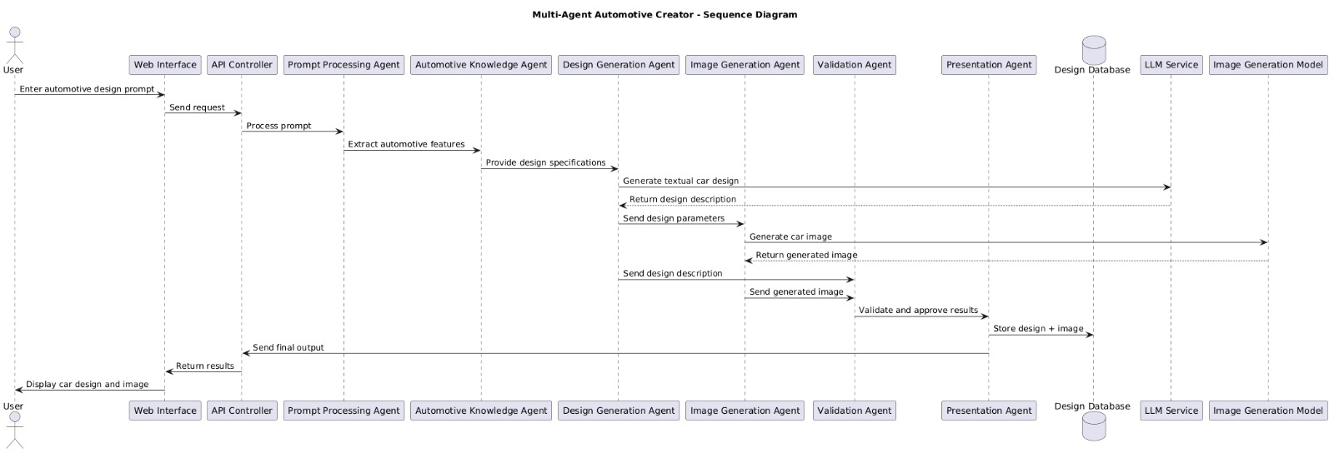

2.Class diagram:-
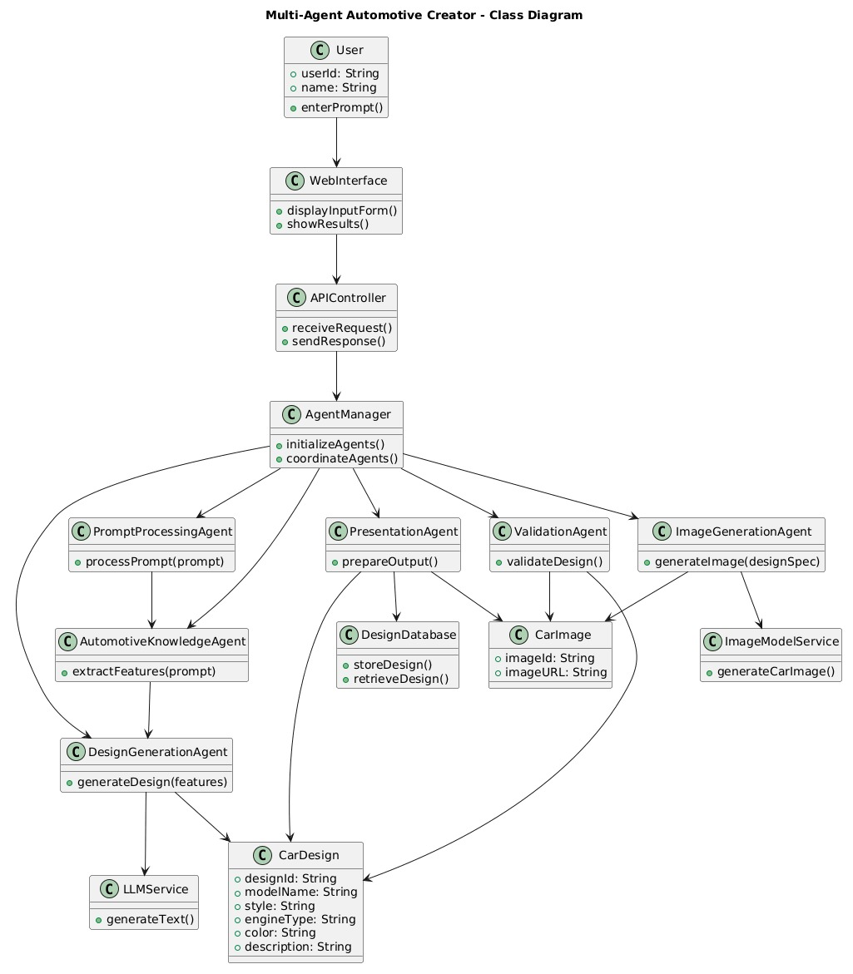

3. Activity diagram:-
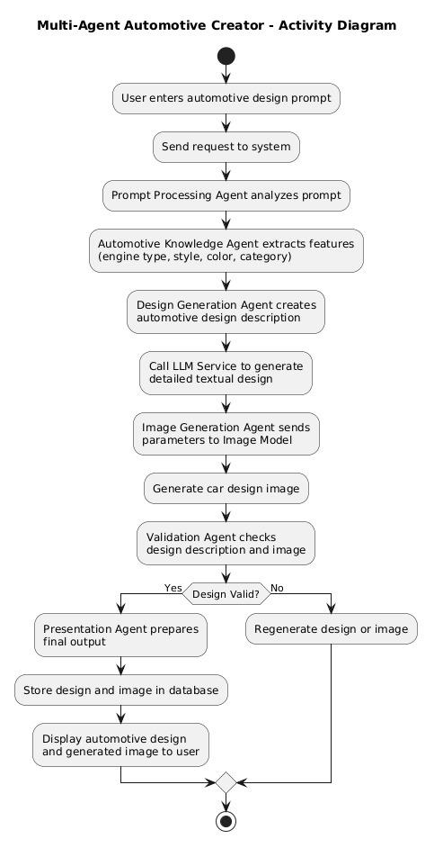

1. User Input Stage
  - The user provides automotive design requirements such as vehicle type, features, and constraints through the interface.

- Requirement Analysis Agent
  - This agent processes and interprets user inputs.
  - Converts raw input into structured data for further processing.
- Orchestrator (Central Controller)
  - Manages communication between all agents.
  - Decides the sequence of task execution.
  - Ensures smooth workflow coordination.
- Configuration Agent
  - Generates suitable vehicle configurations based on analyzed requirements.
  - Defines specifications such as engine type, body style, and features.
- Component Selection Agent
  - Selects appropriate components based on configuration.
  - Ensures compatibility and logical consistency.
- Knowledge/Data Support (Optional Integration)

  - Agents may retrieve relevant data from databases or external sources to improve accuracy.
- Documentation Agent
  - Compiles outputs from all agents.
  - Generates structured automotive design documentation.
- Output Generation
  - Final results are presented to the user in a readable format.
  - Users can modify inputs and regenerate results if needed.

Architecture Summary
- Input Layer: User Interface
- Processing Layer: Multiple Intelligent Agents
- Control Layer: Central Orchestrator
- Output Layer: Generated Configurations + Documentation

3. Tools & Technologies Used
Programming Language
- Python
Frameworks / Libraries
- LangChain / CrewAI (for multi-agent workflow, if used)
- FastAPI / Flask (for backend development)
AI / Agentic Components
- Large Language Models (LLMs) for reasoning and generation
- Rule-based or AI-based decision logic for agents
Database / Storage
SQLite / MongoDB (for storing configurations and data)
Frontend (Optional)
- HTML, CSS, JavaScript
Streamlit (for quick UI development)
Development Tools
- VS Code
- Git & GitHub
Integration Capabilities
- External APIs (if required)
- Knowledge bases or datasets

Results & Output
The Multi-Agent Automotive Creator system was successfully implemented and tested to validate its agent-based workflow. The system demonstrates how multiple intelligent agents collaborate through a centralized orchestration mechanism to automate the automotive design and development process from user requirements to final documentation.

1. Screenshots / Outputs
1.Login page
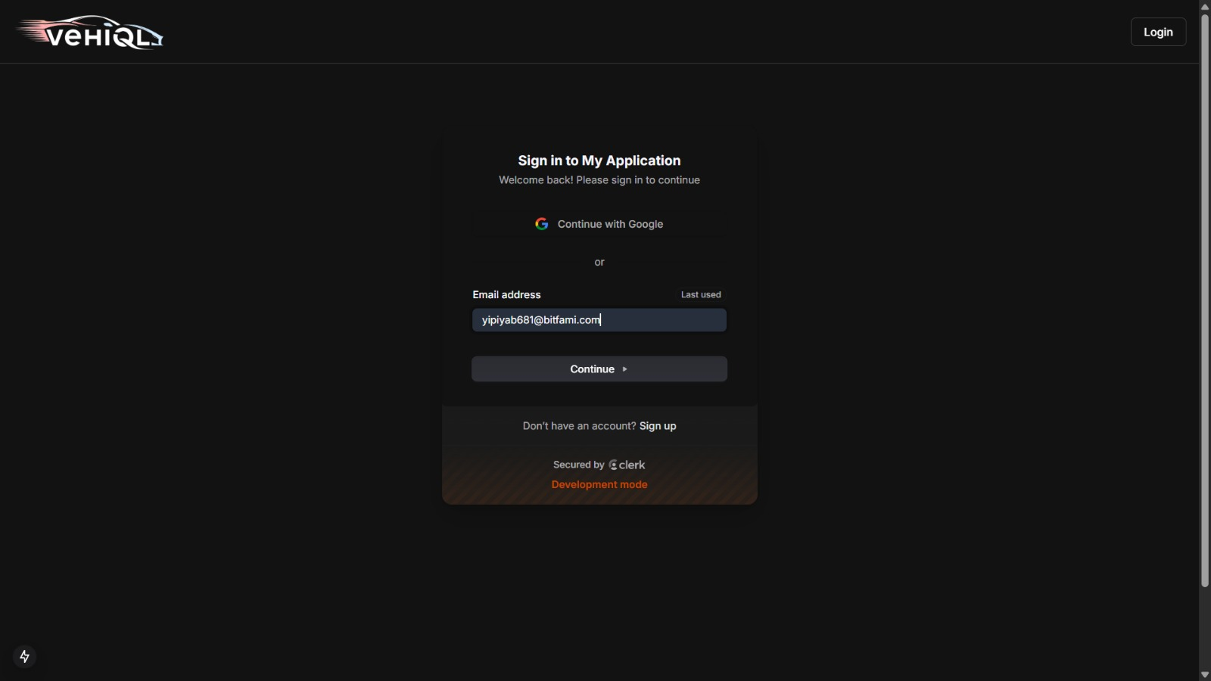

1.Admin portal
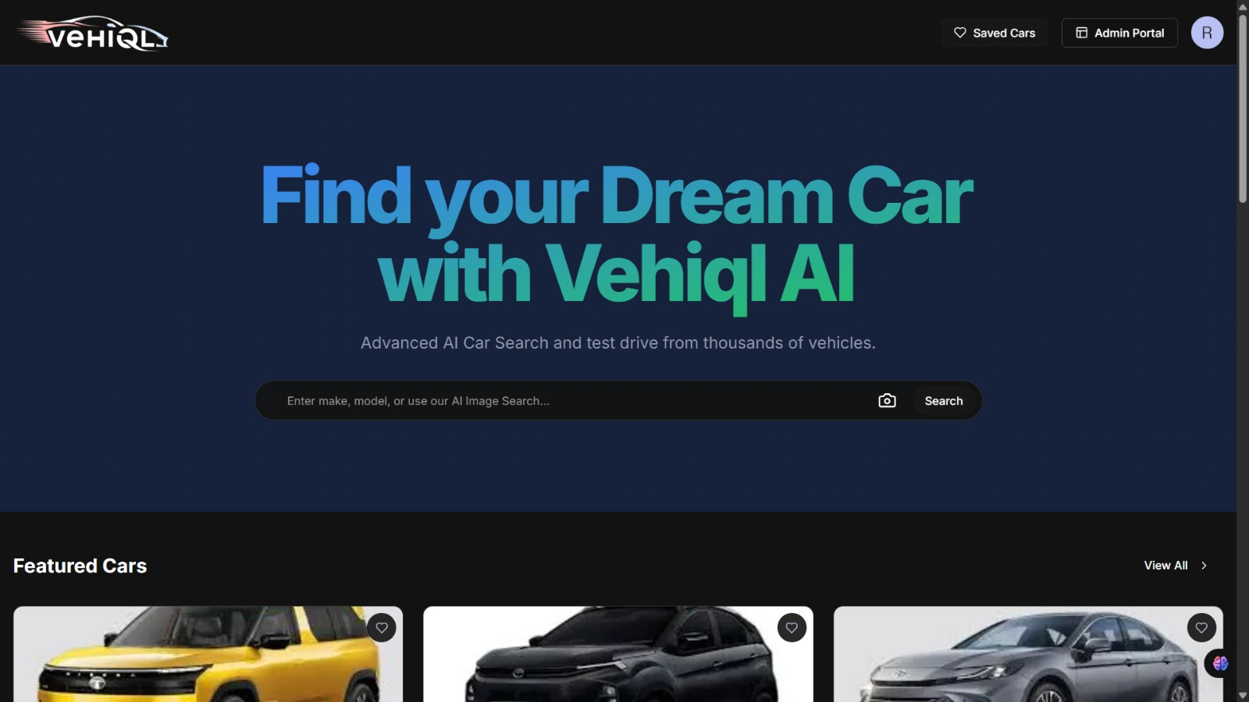

3. Responsive
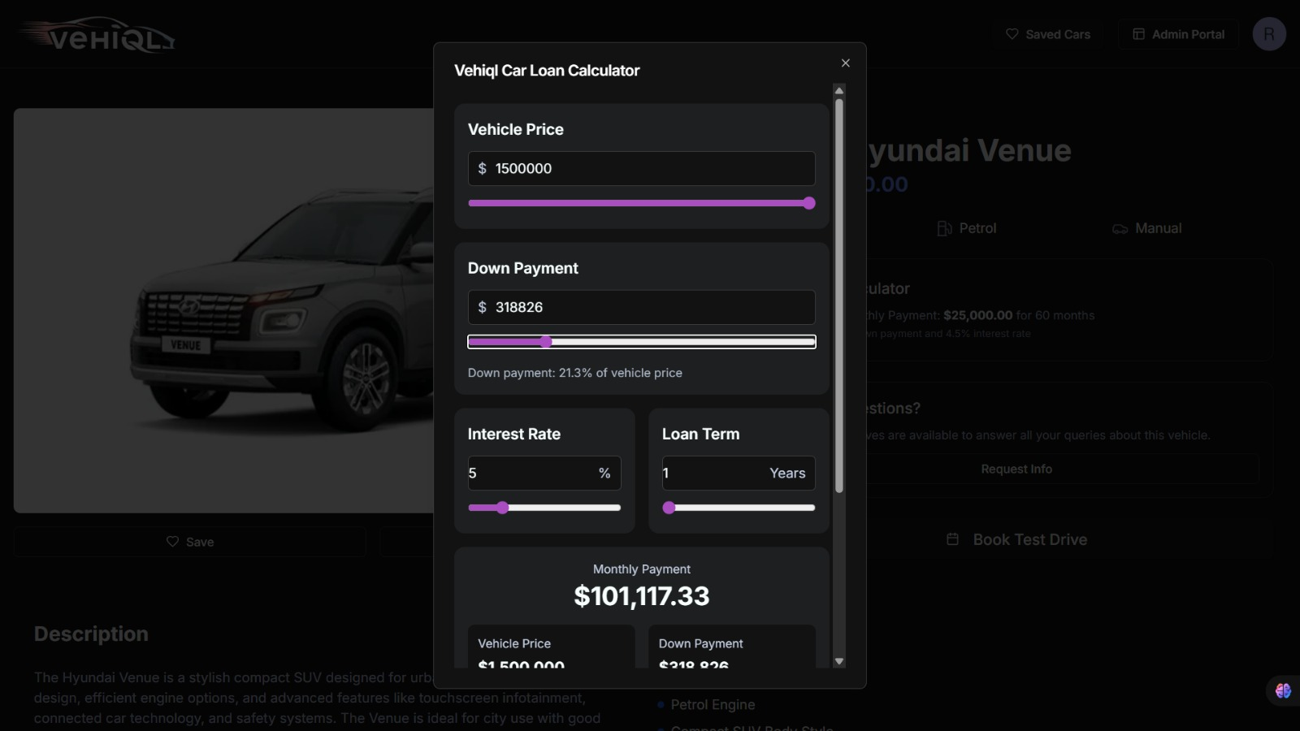

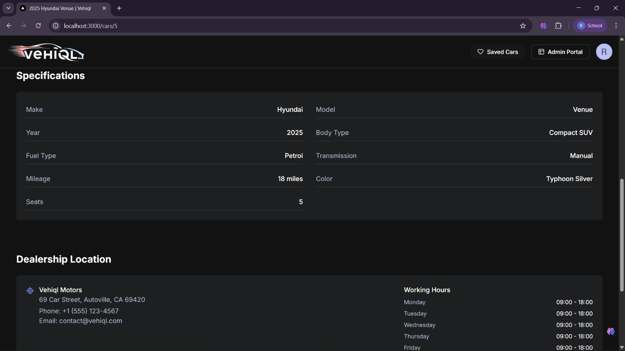

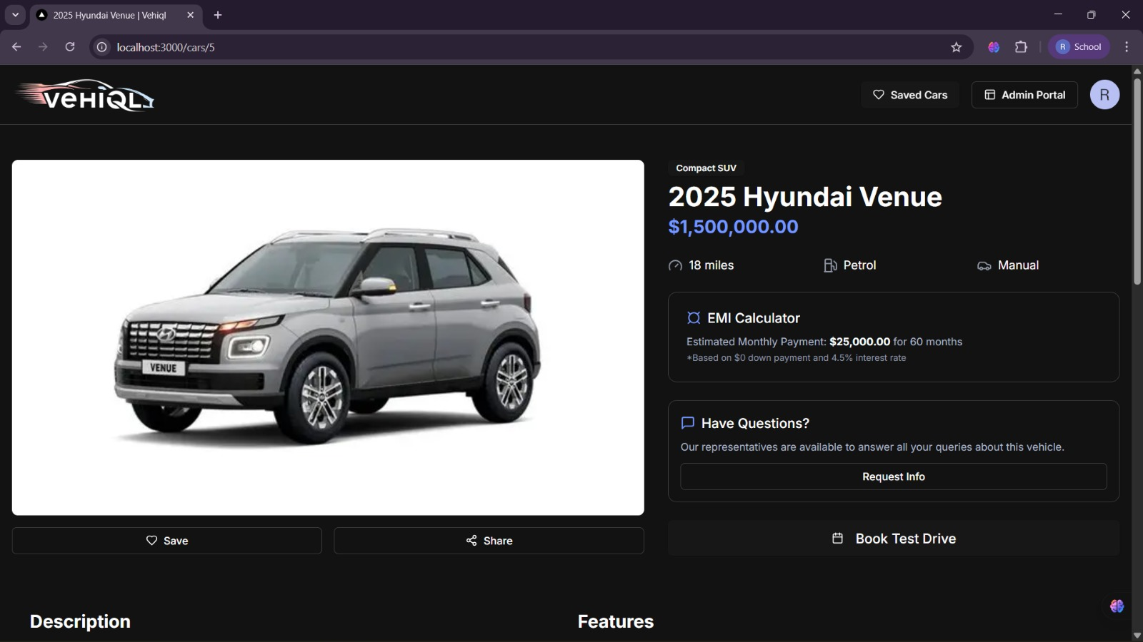

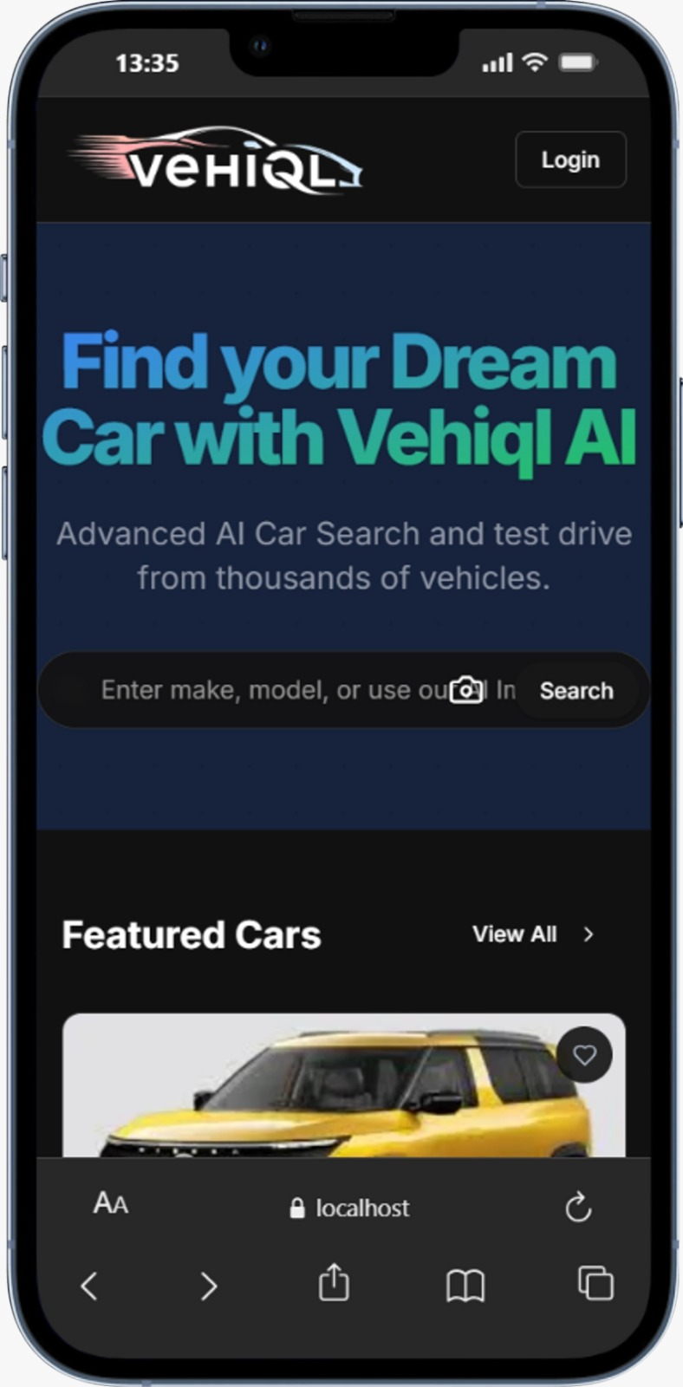

a: User Input Interface
- Web-based interface developed using HTML/CSS or Streamlit.
- Input fields for automotive design requirements (vehicle type, features, constraints).
- “Generate Configuration” button to initiate the workflow.

b: Processed Requirement Output (Requirement Analysis Agent)
The Requirement Analysis Agent successfully processed user input and generated structured data including:
- Vehicle Type (e.g., SUV, Sedan, Electric Vehicle)
- Feature Requirements (e.g., autonomous driving, infotainment system)
Performance Constraints (e.g., range, fuel type, efficiency)
- User Preferences and design priorities
This output confirms accurate interpretation and structuring of raw user input.
Example Input:
“Electric SUV with long range, advanced safety features, and modern interior design suitable for urban and highway driving.”

c: Generated Automotive Configuration (Configuration Agent)
The Configuration Agent produced a detailed vehicle configuration including:
- Body Type: SUV
- Powertrain: Electric motor system
- Battery Capacity: Long-range battery pack
- Key Features: Advanced driver assistance systems, smart connectivity
- Design Aspects: Modern styling with aerodynamic structure
This demonstrates effective transformation of requirements into logical automotive configurations.

d: Component Selection Output (Component Selection Agent)
The Component Selection Agent generated compatible component recommendations such as:

- Battery system and power modules
Safety components and sensors
- Infotainment and control systems
- Structural and material components

The output ensured compatibility and consistency across selected components.
e: Generated Design Documentation (Documentation Agent)
The Documentation Agent compiled outputs from all agents into a structured report including:
- Requirement Summary
- Vehicle Configuration Details
- Component Selection Information
- Final Design Overview
This confirms successful automation of documentation generation.

2. Reports / Dashboards / Models
A. System Workflow Model
The implemented workflow follows a multi-agent pipeline:
User Input
→ Requirement Analysis Agent
→ Orchestrator
→ Configuration Agent
→ Component Selection Agent
→ Documentation Agent
→ Output Display
This model demonstrates effective collaboration between agents and structured workflow execution.

B. Architecture Model
The system architecture consists of:
- Presentation Layer (Frontend UI)
  - Handles user interaction and input
- Application Layer (Python Backend)
  - Implements business logic and agent coordination
- Agent Layer (Multi-Agent System)

  - Requirement Analysis Agent
  - Configuration Agent
  - Component Selection Agent
  - Documentation Agent
- Data Layer (Optional Database / Knowledge Base)
  - Stores automotive data and configurations
This layered architecture ensures modularity, flexibility, and scalability.

C. Performance Observation Report
During system testing:
- Requirement processing time: 1–3 seconds
- Configuration generation time: 2–4 seconds
- Component selection time: 2–5 seconds
- Documentation generation time: 1–2 seconds
Additional observations:
- Smooth coordination between agents via orchestrator
- Accurate and consistent outputs across multiple runs
- Efficient handling of repeated and modified user inputs

No major system failures during execution
The system maintained stability and responsiveness throughout testing.

3. Key Outcomes

1. Successful Containerized Deployment
The automotive application was successfully packaged into containers using Docker, ensuring consistency and portability across different environments.

2. Efficient Orchestration and Management

The application was deployed and managed using Kubernetes, enabling automated scheduling, scaling, and lifecycle management of containers.

3. Improved Scalability
The system can handle increasing user demand by automatically scaling the number of running containers, ensuring smooth performance under high load.

Final Outcome Statement
The Deploy Automotive App To Kubernetes project successfully demonstrates the deployment of a containerized automotive application using Docker and its efficient management through Kubernetes. The final outcome is a scalable, highly available, and fault-tolerant system capable of handling varying workloads. The application is deployed using a microservices architecture, ensuring flexibility and ease of maintenance. Automated CI/CD pipelines streamline the development and deployment process, reducing manual effort and errors. The system also includes monitoring, logging, and security mechanisms, making it reliable and production-ready.
Conclusion
In conclusion, this project highlights the importance of modern DevOps practices and cloud-native technologies in application deployment. By leveraging Docker for containerization and Kubernetes for orchestration, the system achieves scalability, resilience, and efficient resource utilization. The implementation of microservices architecture improves modularity and simplifies system management. Additionally, automation through CI/CD enhances productivity and reduces deployment risks. Overall, the project provides a strong foundation for building and deploying real-world applications in a scalable and secure environment, making it highly relevant for current industry practices.

Key Learnings
• Understanding of containerization using Docker
• Knowledge of container orchestration using Kubernetes
• Implementation of microservices architecture
• Experience with CI/CD pipelines
• Hands-on with deployment automation
• Understanding of load balancing and auto-scaling
• Knowledge of monitoring and logging tools
• Implementation of security practices (RBAC, Secrets)
• Experience with cloud-native application development

• Improved problem-solving in distributed systems.

Future Scope & Enhancements
a. Future Scope
• Integration with cloud platforms (AWS, Azure, GCP) for global deployment
• Implementation of AI/ML for advanced automotive analytics
• Integration with IoT for real-time vehicle data processing
• Multi-region deployment for higher availability and disaster recovery
• Advanced security features (zero-trust architecture, encryption enhancements)
• Performance optimization using advanced caching and load balancing
• Implementation of service mesh (e.g., Istio) for better traffic management
• Real-time monitoring with advanced analytics dashboards
• Support for mobile and web-based user interfaces
• Expansion to handle large-scale enterprise automotive systems
b. Enhancements

1. Cloud Deployment Integration
The project can be enhanced by deploying the application on cloud platforms like AWS, Azure, or GCP. This will improve scalability, availability, and global accessibility of the system.

2. AI/ML Integration

Advanced analytics can be added using AI and Machine Learning to predict vehicle performance, detect faults, and provide intelligent insights for users.

3. IoT Integration
The system can be enhanced by connecting with IoT devices in vehicles to collect real-time data such as location, speed, and engine status for better monitoring and analysis.

4. Advanced Security Implementation
Security can be improved by adding features like end-to-end encryption, multi-factor authentication, and zero-trust architecture to protect sensitive data.

5. Real-Time Data Processing
The system can be enhanced to process data in real-time using streaming technologies, enabling faster decision-making and live analytics.

